Shell-2010-Pecten-RGBpc.wmf

**COG Engineering Nigeria**

**(Asset Support)**

**Gbaran EPF Optimization**

**Opportunity Realisation Note**

Epebiyi, Taiwo

Process Engineer (SPDC-PTE/EUPE)

August 2019

Document Number: **SPDC-2017-02-00000800**

This document is made available subject to the condition that the recipient will neither use nor disclose the contents except as agreed in writing with the copyright owner. Copyright is vested in Shell Petroleum Development Company Ltd. © All rights reserved. Neither the whole nor any part of this document may be reproduced or distributed in any form or by any means (electronic, mechanical, reprographic, recording or otherwise) without the prior written consent of the copyright owner.

Up to two lines if required

Document Revision: **A01**

Security Classification: Restricted

Security Classification: Restricted

**Revision History**

|  |  |  |  |  |  |
| --- | --- | --- | --- | --- | --- |
| **REVISION STATUS** | | | **SIGNATORIES** | | |
| **Rev.** | **Date** | **Description** | **Originator** | **Reviewer** | **Approver** |
| R01 | 01/08/2019 | Issued for Review | T. Epebiyi | S. Moni-Nwinia | T. Erekosima |
|  |  |  |  |  |  |
|  |  |  |  |  |  |
|  |  |  |  |  |  |
| * Preliminary issue will be issued as P01 * Revisions for review will be issued as R01, with subsequent come as R02 etc. * Revisions approved for Implementation/Design Issue/Eng. will be issued as A01, with subsequent come as A02 etc. * Revisions approved for Tender will be issued as T01, with subsequent come as T02 etc. * Revisions approved for Construction (AFC)/Purchase will be issued as C01; with subsequent comes as C02 etc. * Highlights of sections revised from previous approved issues or reasons for version change are to be listed in the description box * All revisions to this document must be signed by the relevant Technical Authority (TA1, TA2 or TA3) | | | | | |

**Signatures for this Revision**

|  |  |  |  |
| --- | --- | --- | --- |
| **Role** | **Name** | **Signature** | **Date** |
| **Originator** | Taiwo Epebiyi |  |  |
| **Reviewer** | Moni-Nwinia, Suanu |  |  |
| **Approver** | Tonye, Erekosima |  |  |

**CONTRIBUTORS**

|  |  |
| --- | --- |
| **Name** | **Role** |
|  |  |
|  |  |
|  |  |

Security Classification: Restricted

**TABLE OF CONTENTS**

LIST OF ABBREVIATIONS 4

EXECUTIVE SUMMARY 5

1. Project Background 5

1.1. Project Value Drivers 7

1.2. Purpose 7

1.4. Routing of Dehydrated Gas to the EPF 9

2.3. Scope of Design Work and Deliverables 12

3. References 13

4. Appendix 17

# LIST OF ABBREVIATIONS

CAPEX- Capital Expenditure

CPF- Central Processing Facility

DED- Detailed Engineering Design

EPF – Early Production Facility

FEED Front-end Engineering Design

GP – Gas Plant

HAZOP - Hazard and Operability Study

HP -High Pressure

LCV- Level Control Valve

NAG – Non- Associated Gas

NLNG - Nigeria Liquefied Natural Gas

NIPP – National Integrated Power Plant

JT-LTS – Joule Thompson – Low Temperature Separator

# EXECUTIVE SUMMARY

The Gbaran Early Production Facility (EPF) was designed with the primary aim of achieving short term gas supply of about 80 MMscfd to National Integrated Power Plant (NIPP). The Gbaran EPF receives gas from Gbaran wells 11T & 13T which can also be re-routed to Gbaran CPF for production in the event of NIPP outage.

Production forecast for Gbaran 11T & 13T from the subsurface team reveals that the production decline is expected, hence a long-term gas supply plan to the NIPP is required.

This report presents a clear strategy to sustain gas supply to the NIPP after the depletion of Gbaran 11T & 13T wells. As part of the study, two tie-in options were reviewed;

* Routing of dehydrated gas from the Dehydration Manifold to the EPF.
* Backflow Wet Gas from the Gbaran NAG Manifold at the CPF to the EPF

The two tie-in options were evaluated and the most optimal involves a tie-in from the dehydration manifold. This modification will lead to the mothball of several units in the EPF such as; choke valve at the facility inlet, heaters upstream and downstream the choke, gas-liquid heat exchanger and EG regeneration package accounting for majority of the facility. The JT-LTS system will be retained to meet the pressure and dew-point specification of the NIPP of maximum15deg.C @35barg.

This opportunity involves routing of dehydrated gas from the dehydration outlet manifold to the Gbaran 13T piping and subsequently routed to the EPF for onward processing and transport to NIPP, To accommodate the current NIPP gas supply and maximize the EPF capacity a 10” line will used to route flow of circa 100 MMscfd.

# Project Background

The primary aim of the Gbaran EPF is to fulfil SPDC’s commitment to the supply of about 80 MMscfd of fuel gas to the National Independent Power Plant in Gbaran. The Gbaran EPF was designed and built to industry standards to act as short-term gas supply option for the NIPP to meet the initial scheduled IPP start-up date of September 2009.

The EPF is a processing plant built to process NAG for fuel gas supply to the FGIPP at hydrocarbon and water dewpoint of 15 deg.C (max) at 35 barg using the JT- LTS process (to remove the hydrocarbon heavy ends) and glycol to strip the gas of water/prevent hydrate formation.

The incoming high-pressure NAG well fluid (from Gbaran wells 11 and 13) is first heated up in a preheater after which the pressure is dropped to about 100 barg via a choke valve. The preheating helps prevent hydrate formation that could arise from the choking process. The temperature is recovered in a post-heater. Currently these heaters are bypassed since they are no longer required based on current pressures and temperatures of the gas.

The stream is further flashed in a production separator which operates at about 86 barg where heavy hydrocarbons liquids and free water are removed before entering the JT-LTS system. The off gas is injected with di-ethylene glycol to prevent hydrate formation as the pressure is dropped via a JT-valve to about 40 barg. The pressure drop via the JT-valve gives rise to a corresponding temperature drop which results in condensation of the heavy ends in the gas. The liquid hydrocarbon and glycol/water mixture is separated in a cold separator which is a three-phase separator. The off gas from the cold separator gains heat from the hot gas upstream the JT-valve via the gas-gas heat exchanger where its temperature is raised to about 15 - 50oC before it is metered and delivered to the FGIPP. Used glycol is then regenerated in the glycol regeneration unit.

Currently, wells 11 and 13 pressure and rates are declining hence, threatening the supply of gas to the NIPP. A solution is required to ensure DOMGAS supply is sustained to the NIPP

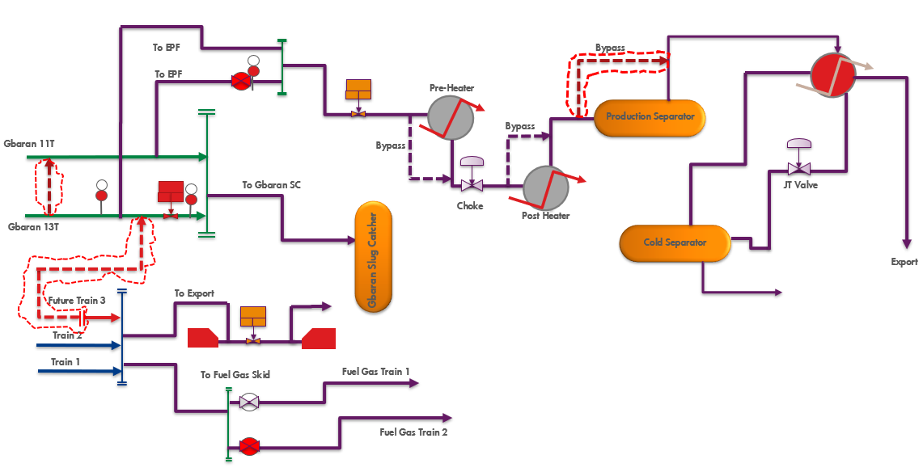

Fig 1. Process Flow Schematic – Routing of Dehydrated Gas to EPF

# Project Value Drivers

The value driver for this project is sustaining gas supply to NIPP. Much value will be derived from this project if the modification can be in place before the expected production decline from the Gbaran 11 & 13 wells

In addition, there are plans to upgrade the EPF but with this opportunity where only the JT-LTS system will be majorly used, this will mean CAPEX savings from the planned upgrade since most of the equipment will be permanently disused and will not require upgrade.

In summary, this opportunity ensures:

• Security of DOMGAS supply of up to 80MMScfd beyond wells 11 and 13 production.

• EPF OPEX savings from using glycol, facility daily operations and maintenance.

• EPF upgrade CAPEX savings.

• Manpower resource re-assignment for a more effective Production Unit.

# Purpose

The purpose of this document is to set out the basis for the proposed modifications required to achieve the desired goals, describe the concept as well as highlight possible challenges and planned mitigation measures considered.

* 1. **Opportunity Description** 
     1. **EPF Process System**

The Gbaran EPF is necessary for security of DOMGAS supply but due to pressure/production decline of Gbaran 11T and 13T. This opportunity will provide some cost savings by permanently disusing the glycol system and the heaters in the EPF due to dehydrated feed gas

* + 1. **Option 1 – Do Nothing/ Continue with Existing Configuration**

This option requires that dedicated Gbaran 11 & 13 wells continue to flow to Gbaran EPF as dedicated gas supply

**Pro(s)**

* No additional modification required, System already in place.

**Con(s)**

* Decline in production from well 11 & 13 resulting in loss of gas supply to NIPP
  + 1. **Option 2 – Routing of Export Gas from CPF to EPF**

This option involves routing of dehydrated gas from the dehydration outlet manifold just upstream the export meters and requires construction and installation of piping of about 300m to tap-off gas from the available tie-in point. This is the preferred option because it minimizes the brown-field work-scope in the CPF and ensures steady supply of dehydrated gas to the EPF.

**Pro(s)**

* Constant supply of dehydrated gas to the EPF
* Improved energy efficiency of the Early Production Facility
* OPEX savings on EPF
* Minor construction works required

**Con(s)**

* Brownfield modifications required at the Gbaran CPF
* Implementation will need to tie into an existing shutdown window
  + 1. **Option 3 - Routing Wet Gas from the Gbaran NAG Manifold from CPF to the EPF**

This entails routing of wet gas from the Gbaran NAG Inlet Manifold upstream the Gbaran NAG slug catcher to the Gbaran EPF. This would involve the installation of a Flow Control Valve, a Flow Indicator Control and Alarm (FICA) and the reversal of the Check Valve.

**Pro(s)**

* Minimal pipe routing/modification works in the CPF

**Con(s)**

* Routing of Wet Gas to the EPF
* Cost of additional piping and fittings

Option 2 was selected as the most preferred. The main advantage of Option 2 is that it provides dehydrated gas as feed for the EPF, this ensures a few equipment can be mothballed with associated OPEX and CAPEX savings. This also improves the corrosion management for the EPF due to use of dehydrated gas as inlet feed. In addition, the work-scope at the CPF & EPF is minimal.

# Routing of Dehydrated Gas to the EPF

* + 1. **Feed Composition & Basis**

Fluid Package: Peng Robinson

Inlet Fluid Compositions are specified below

Table 3.5 - Dehydrated Gas Case Feed Composition

|  |  |
| --- | --- |
| **Components, Units** |  |
| Pressure | 96.10 |
| Temperature | 40 |
| Molar Flow (MMSCFD) | 100 |
| Nitrogen | 0.00105 |
| CO2 | 0.01080 |
| Methane | 0.90023 |
| Ethane | 0.05040 |
| Propane | 0.01850 |
| i-Butane | 0.00358 |
| n-Butane | 0.00458 |
| i-Pentane | 0.00177 |
| n-Pentane | 0.00129 |
| n-Hexane | 0.00075 |
| C7+ | 0.00705 |
| E-Glycol | 0.00000 |
| H2O | 0.00000 |
| Total | 1.00000 |
| **Hypo-components** | **Composition** |
| _CP * | 0.00187 |
| _CH * | 0.00271 |
| _NC5 * | 0.00112 |
| _NC6 * | 0.00056 |
| _BNZN* | 0.00051 |
| _BCH * | 0.00023 |
| _NPHT* | 0.00004 |
| _X180* | 0.00000 |
| _15A * | 0.00001 |
| _X350* | 0.00000 |
| _28B * | 0.00000 |
| _NC10* | 0.00000 |
| _NC16* | 0.00000 |
| _29A * | 0.00000 |
| _X580* | 0.00000 |
| _X600* | 0.00000 |
| _X800* | 0.00000 |
| _X820* | 0.00000 |

The hypo-components properties are specified;

Table 3.6 - Hypo-component properties

|  |  |  |  |  |  |  |  |
| --- | --- | --- | --- | --- | --- | --- | --- |
| **Name** | **NBP [C]** | **MW** | **Liq Density [kg/m3]** | **Tc [C]** | **Pc [bar_g]** | **Vc [m3/kgmole]** | **Acentricity** |
| _CP * | 44.70 | 70.14 | 750.46 | 231.64 | 43.48 | 0.26 | 0.17 |
| _CH * | 80.44 | 84.16 | 783.36 | 274.94 | 38.62 | 0.31 | 0.23 |
| _NC5 * | 21.67 | 72.15 | 631.17 | 183.26 | 33.39 | 0.30 | 0.18 |
| _NC6 * | 60.70 | 86.18 | 663.97 | 227.00 | 29.40 | 0.36 | 0.27 |
| _BCH * | 174.01 | 140.27 | 803.16 | 367.34 | 24.28 | 0.55 | 0.38 |
| _NC10* | 162.15 | 142.29 | 734.06 | 335.93 | 20.58 | 0.60 | 0.42 |
| _BNZN* | 84.63 | 78.11 | 884.56 | 296.94 | 49.08 | 0.26 | 0.20 |
| _NPHT* | 200.13 | 128.17 | 1030.95 | 445.30 | 38.89 | 0.39 | 0.31 |
| _X180* | 291.24 | 180.00 | 1099.95 | 548.45 | 31.25 | 0.54 | 0.40 |
| _15A * | 260.81 | 204.36 | 859.06 | 457.49 | 18.56 | 0.78 | 0.48 |
| _NC16* | 260.80 | 226.45 | 777.26 | 429.03 | 13.90 | 0.97 | 0.58 |
| _28B * | 416.09 | 380.62 | 898.46 | 588.28 | 10.00 | 1.53 | 0.87 |
| _29A * | 412.81 | 400.69 | 853.56 | 566.81 | 8.45 | 1.71 | 0.99 |
| _X350* | 466.64 | 350.00 | 1099.95 | 702.07 | 15.70 | 1.16 | 0.74 |
| _X580* | 622.51 | 580.00 | 1099.95 | 823.14 | 8.81 | 2.08 | 1.24 |
| _X600* | 560.90 | 600.00 | 944.85 | 708.99 | 6.25 | 2.49 | 1.37 |
| _X800* | 734.63 | 800.00 | 1099.95 | 907.40 | 6.17 | 2.97 | 1.62 |
| _X820* | 667.37 | 820.00 | 959.05 | 787.96 | 4.48 | 3.47 | 1.78 |

* + 1. **EPF Facility – Operating Limit**

Capacity Checks including operating limit for the EPF facility indicates the capacity of the facility as 88 MMscfd. The figure below shows the distribution of the capacity of each of the units within the facility. This opportunity will allow the use of only the JT-LTS Package and the

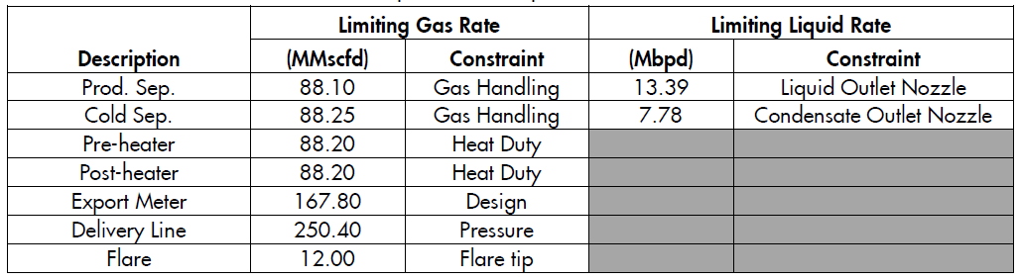

1. **Proposed Modifications**
   1. **Concept Selected**

The concept selected involves routing 80 MMscfd of dehydrated export gas from Gbaran CPF Export Manifold to the Gbaran Well 11/13 flowline en-route to the EPF, one of the well flowlines will be used to route the total production of Well 11 & 13 to the Gbaran Dehydration Inlet Manifold where they will be produced to the Gbaran Slug catcher, while the other flowline (Gbaran 13T) will be used to route the dehydrated gas from the CPF to the EPF

As at June 2019, the average production and NIPP nomination has been in the range 22 -25MMscfd. It is expected that a future growth case will be catered for by this opportunity.

In this concept the heaters (Pre-& Post Heaters) will be bypassed and the main processing unit in the EPF will be the JT-LTS Package which will achieve the required NIPP export pressure and specification.



Fig 1.2. Schematic - Concept for Routing Dehydrated Gas to EPF

* 1. **Work scope**

This section itemizes the scope of the modification(s) required at Gbaran CPF and the EPF, Dehydrated gas will be tapped off using the available 20” ligament (Future Train 3 ligament) of the metering header to tie into the Gbaran 11 or 13 flowline at the Gbaran NAG manifold, the work-scope is listed below;

* Design & Installation of 10”x 900# Piping from the available 20” Ligament (Future Train 3 Ligament) to the Gbaran 11T Flowline in the CPF.
* Piping connection to route (Gbaran 11T + Gbaran 13T) combined wet gas flow through a single flowline to the Gbaran NAG Dehydration manifold.
* Construction of Piping to bypass the Production separator in the EPF.
* Decommissioning of preheater, post-heater, production separator (and associated instrument), gas/liquid heat exchanger and the Glycol Regeneration Unit.
* Instrument Integration to ensure the instruments in the EPF JT-LTS system is integrated into the Gbaran CPF Control and Safeguarding system.
* Other engineering checks as needed for brownfield modification.

# Scope of Design Work and Deliverables

The Detailed Engineering Design Scope of work also includes validation of the following;

* Line Sizing
* Process Design Report
* Piping Stress Analysis
* Piping Isometrics
* Piping Base Foundation Design
* Materials Take-off and Construction Scope/Package
* Systematic HAZOP analysis
* Update of all affected drawings and documentation
  1. **Deliverables/Activities**

Process Engineering

* Preparation/Update of PFS/PEFS/PSFS
* Preparation/Update of Heat and Mass balance
* Preparation of Process Design Report
* Update of Gbaran EPF Operating and Control Philosophy

PACO

* Design integration of the EPF JT-LTS instruments into the existing Gbaran CPF PAS and SIS system such that seamless integration can be achieved.

Mechanical (Piping)

* Constructability Study Report
* Updated Plot plan drawings and Overall plant layout
* Demolition drawings
* Isometric drawings
* Pipe support drawing and schedule
* Tie-in points and schedule
* MTO
* Stress analysis
* Functional specification
* PDMS model (new, update existing)
* Pipe stress analysis report

Civil

* Civil Design report
* Layout, elevations drawings
* Updated plot plan
* Design of pipe supports and new support foundation layout
* Bulk MTO

HSSE

* HSSE-SP Activity plan
* HSSE-SP Premise/philosophy
* Carry out HAZOP review (TOR, Report and Close out report).

# References

* Gbaran EPF/CPF As-Built Drawings
* Gbaran EPF Operating Envelope

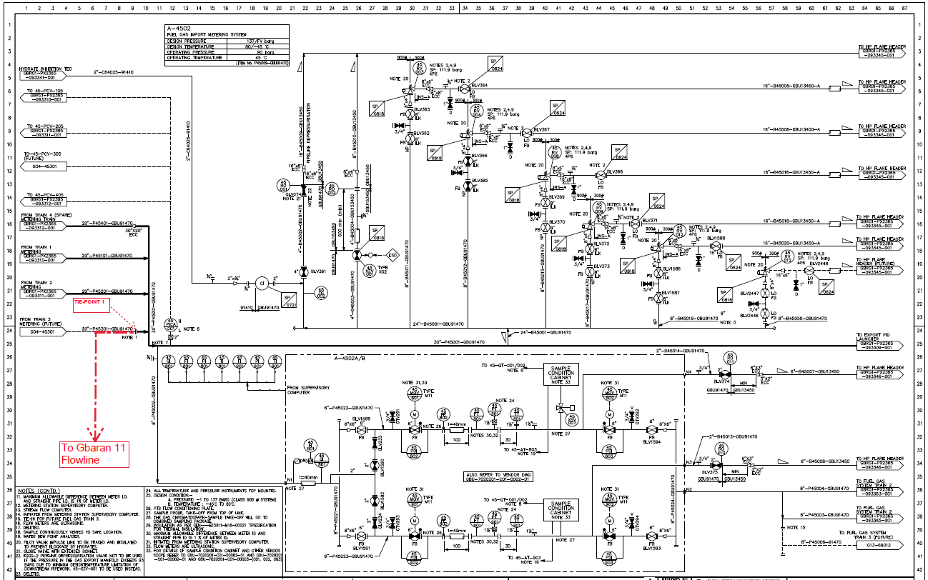

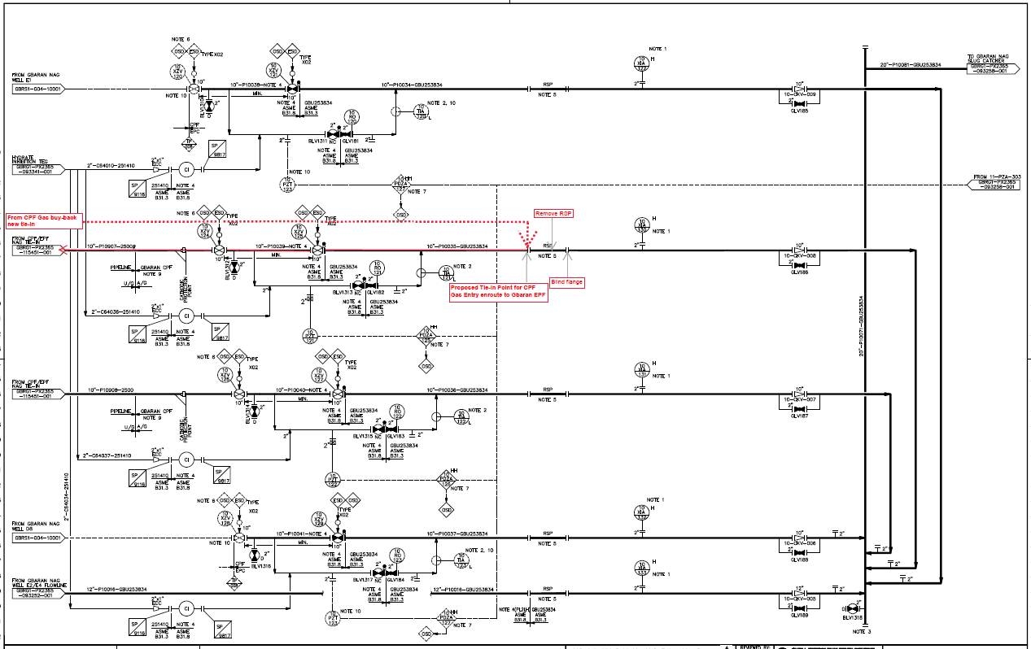

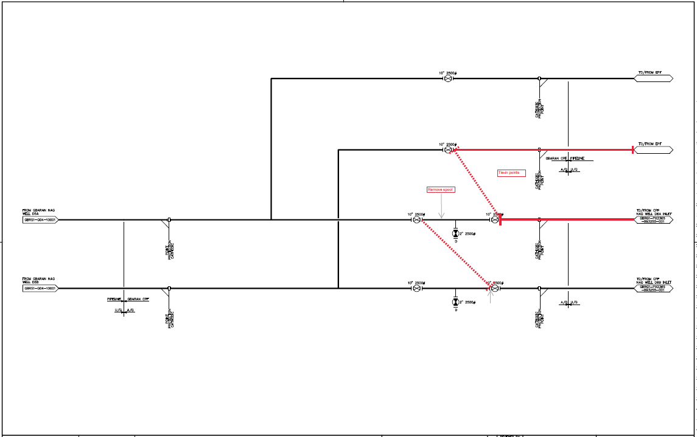

Proposed Tie-in Point

From LP NAG Inlet Separator Gas Outlet Line

Appendix 1: Proposed Marked-up Drawings showing Tie-in scope

# Appendix

* Marked-up PEFS

